3.3 I can work with a team using a range of tools and techniques  
During our week of work doing our team project we used several tools and techniques including:

**Trello**

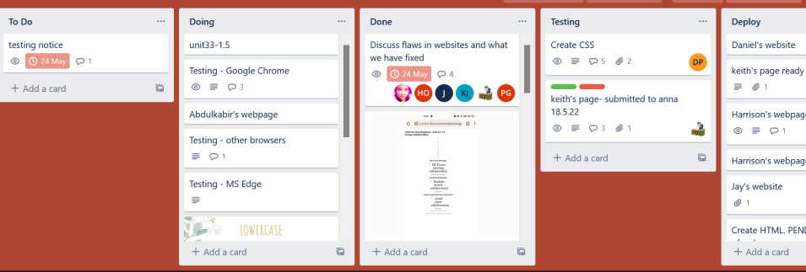

[Above shows an image of our Trello board]

This tool provided us with a way of delegating tasks and a timeline of what they were done and what needed to be done alongside which task. We could also attached files and share ideas in the cards which proved easier than emailing or just discussing things in our MS Teams meetings.

**Gantt chart**

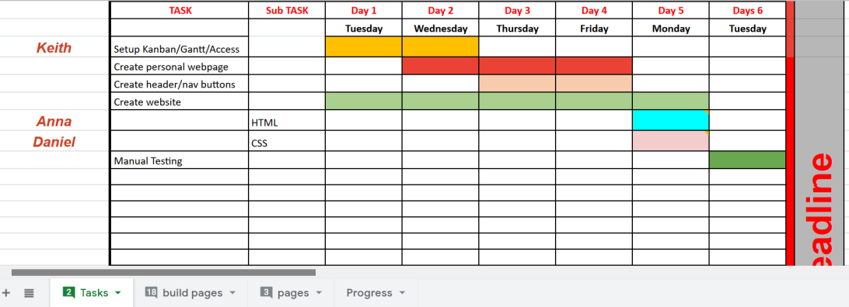

[Above shows an image of our Gantt chart]

The Gantt chart provided us with an overview what needed done by each day and a clear overview of our progress on each day and if we had hit our deadline or not.

Some of a Gantt Chart was adjusted with new dates when we realised that we couldn’t complete it on time in the beginning.

**Microsoft Visual Studio**

This was used to create our web pages and our CSS for each person and combine them all for the whole project. We shared our screens during our MS Teams meetings and showed how each HTML coding file should look like as we were aiming to do each page separate as our own project and then we would work together to figure out what needed to be on the CSS and then do the coding during our own time doing the project.

**Agile method**

This was a technique we used to do each task and work out what tasks we would do alongside that task, E.g working on the code and then testing it to make sure it functioned. We also complied a list every day of what we needed to do so that each task alongside each other was done in the correct order.

**W3validator**

We used this tool to check our code and share our findings on what the website said worked and what was up to standard etc. Obsolete code like <center> was listed on the error list but we didn’t have to remove the code as it still functioned.